SOP – Primary Ordering by Distributor
What is RCPL DMS Platform for Distributor?
DMS platform is an interface provided to distributors of the RCPL Business to:
View the retailer orders placed by the CSO’s, take action (accept/modify/reject) against each of the orders, return the retailer orders, print invoice and picklist.

Step 1: How to Login to RCPL DMS Platform?
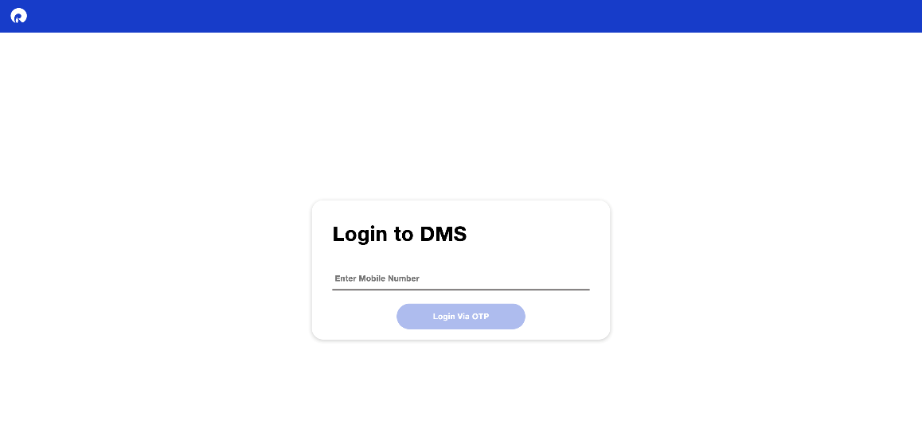

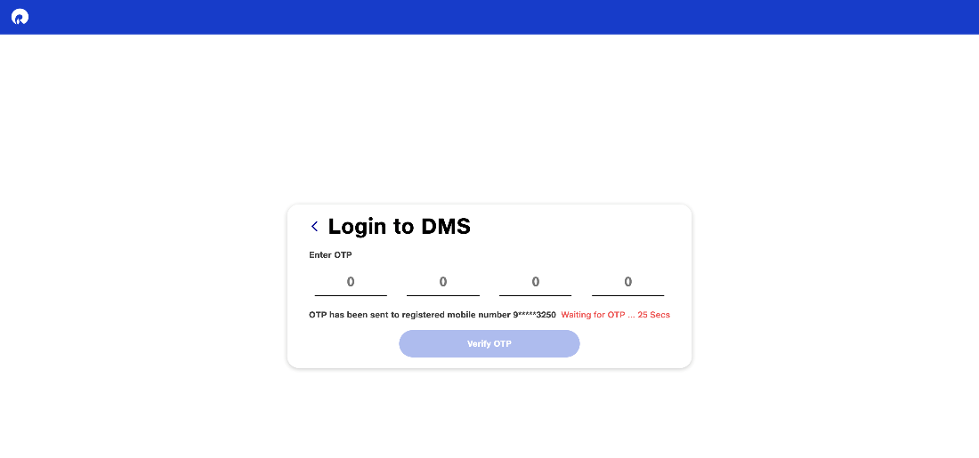
1 a) Open the website url “https://reliancedms.jiomartpartners.com” on any browser
1 b) You will see the welcome screen requesting you to enter the mobile number.
1 d) Entering the mobile number would trigger OTP request screen.
1 e) On entering the correct OTP, you will get logged in to the platform.

Step 2: How to view the retailer orders?
2 a) Upon successful login, the distributor will be able to view the below home page
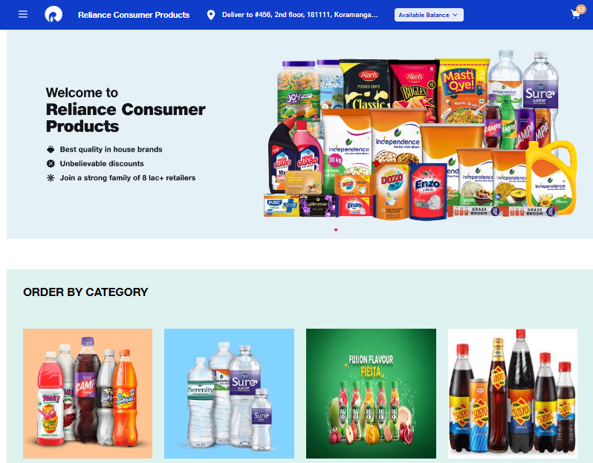
2 b) Upon successful login, you will be able to view the below home page, where you can find the categories listed as: Sparkling Drinks, Soda, Juice, Water, Energy Drinks
2 b) You can choose from the mentioned categories and will land on this screen.
2 c) On this page, select from the available filter pack-sizes: 200 ml / 500 ml/ 1 ltr/ 2 ltr.
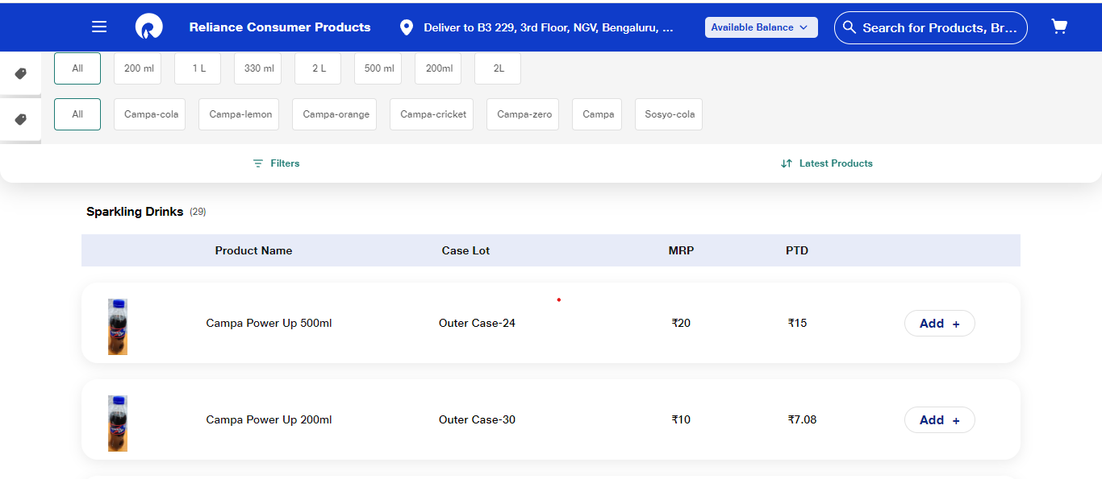
2 d) The screen would show the products for you to add-to-cart. You can click on the ‘Add’ button and type the necessary quantity in cases.

2 e) Add the necessary quantity of items to the cart and click on ‘Go-To-Cart' for landing on the cart page:

2 f) The Full Truck Load progress at the bottom of the cart helps you understand the available truck ton capacity and how much has been attained by the items in the current cart. By removing/ adding to the cart, complete a full truck load. Then the proceed button gets activated.

2 g) The distributor available would be checked against the cart value. The distributor would be able to proceed with the order only if the necessary balance is available

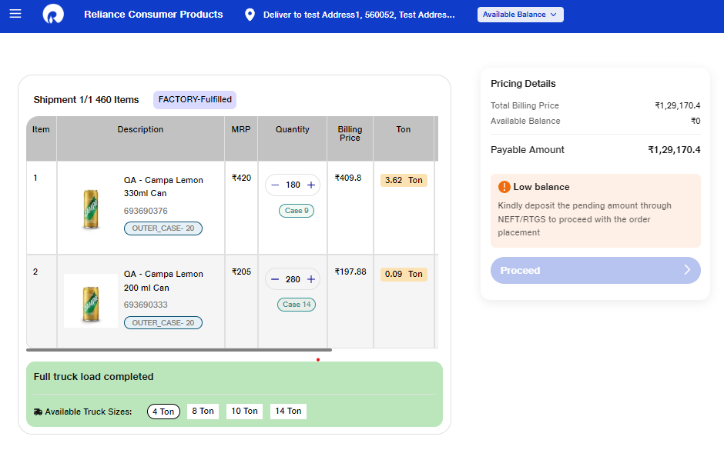

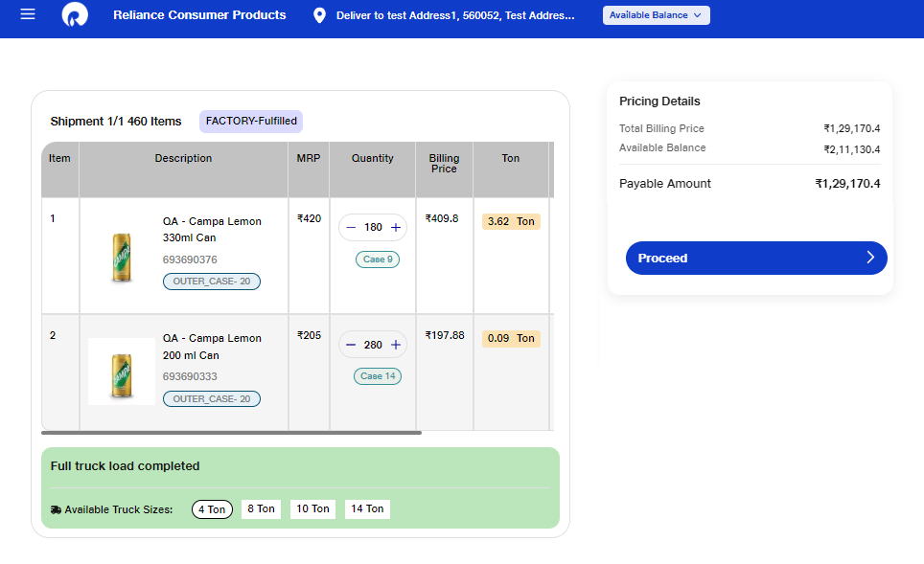

2 g) On clicking ‘Order Now’ you place the order and land you on a page showing the order ID of successfully placed order.

